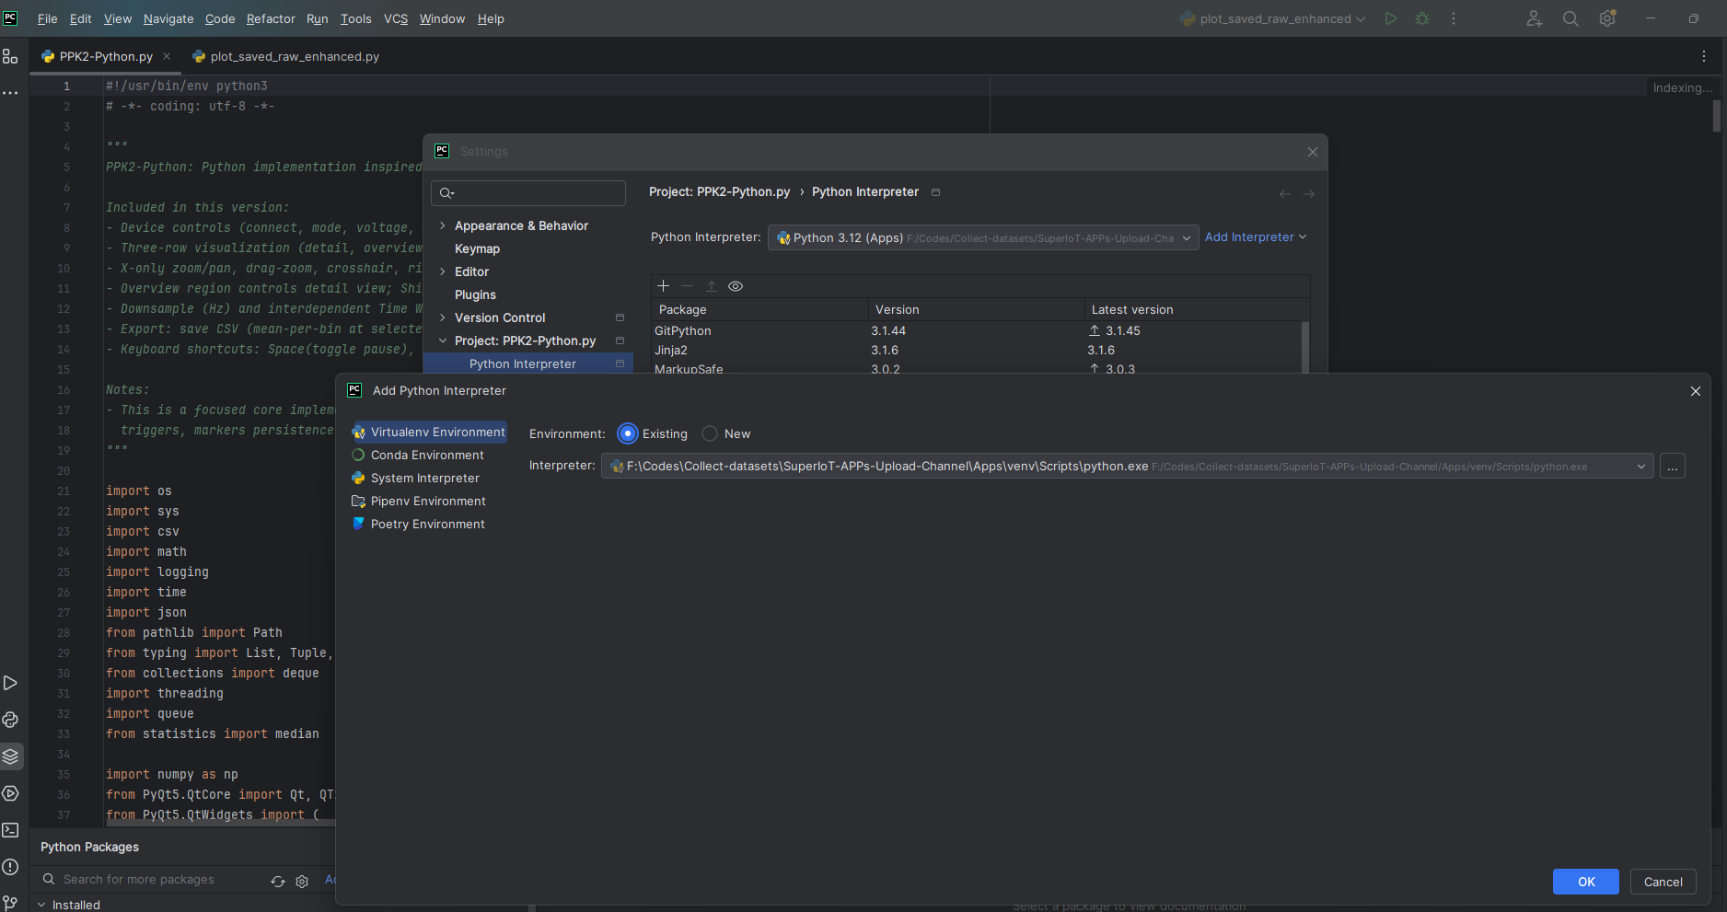

Interpreter Path:
XXXXX \SuperIoT-APPs-Upload-Channel\Apps\venv\Scripts\python.exe

